2013 South Shore Midwest Pocket Billiards Championships Official Entry Form
Name: ______________________________________ Address: ____________________________________________
City: ________________________________________ State: _____ Zip Code: __________ Date: _____________
Home Phone: _________________________________ Cell Phone: __________________________________________
League Name:_________________________________ E-Mail: _____________________________________________
Check league affiliation: ACS ____APA____ BCAPL____ VNEA____ TAP____ UPA ____Other_______________________
Wednesday October 9, 2013
Open 9-Ball 3:00 PM Men _____ Women _______ $50.00 ____________________
Thursday October 10, 2013
Open Seniors 8-Ball (No Masters) 50+ 1:00pm Men _______ Women _______ $50.00 ________________
A-- Open 8-Ball Division 1:00 PM __________ B—Open 8-Ball Division 4:00 PM ________ $50.00 _______________
Open 8-Ball Women Division 6:00 PM _________ $50.00 ________________
Master/Advanced 8-Ball Division 8pm Men _____ Women ______ $50.00 ____________
Note: Open A & B players may play Open and Masters Divisions simultaneously (two events)
Scotch Doubles, male/female, registration TBA, with on-site registration
Friday October 11, 2013
3-Player Team Division (1 mstr/advncd limit) 7:00 PM Men ______ Women ______ $150.00 _________________
Captain: Name ____________________________ Address _______________________________________
City __________________________ State _____ Zip ______ Team Name ________________________________
Cell Phone ________________________________ E-mail ___________________________________________

#2 Name _________________________________ Address _____________________________________
City __________________________________________ State _________ Zip ____________________
Cell Phone ________________________________ E-mail ___________________________________

#3 Name _________________________________ Address ______________________________________
City ________________________________________ State ________ Zip _________________________
Cell Phone ________________________________ E-mail _____________________________________

#4 Name _________________________________ Address ________________________________________
City _______________________________________State ________ Zip ________________________
Cell Phone _______________________________ E-mail ___________________________________________

$15 singles and $60 team Green fee included to each event entry, Total Amount Enclosed ______________
Mail check or money order and entry to: Midwest Services, 2658 Carmen St, Portage, Indiana, 46368
Details: Cecil Messer, (219) 465-8101, E-mail; cmessermidwst@frontier.com; web; www.gmpaonline.info
** A DRESS CODE WILL BE IN EFFECT FOR THIS TOURNAMENT! **
The Tournament Director has the right to place anyone as master or professional skill level based on known ability. No professional players allowed as ranked by WPA, UPA, WPBA, or AZ Billiards. The Tournament Director reserves the right to change the races based on time allotments.
I have read and understand the conditions and the rules set forth for the events entered, expanded rules are on the accompanying page. I understand that it is an honor and a privilege to participate in the 2013 South Shore Midwest Pocket Billiards Championships. I will conduct myself at the highest level while demonstrating good sportsmanship at this national event.
Signature _____________________________________________________ Date _________________________
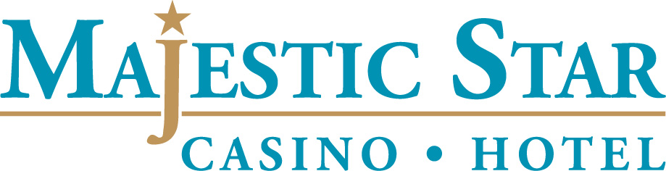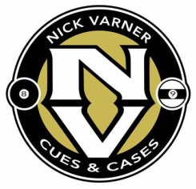
2013 South Shore Midwest Pocket Billiards Championships Please, read these rules and guidelines. You will be responsible for complying with the dress code and all other rules at all times during the tournament. Professional Referees will be provided and will be the sole authority for the rules and the dress code. Other information found on; www.gmpaonline.info.
RULES: All play will be governed by the World Standardized Rules with the following tournament exceptions: for 8-ball it will be Ball-in-Hand on all fouls including the opening break, rack your own balls when it is your break, flip for the opening break then alternate breaks, a 30 second shot clock will be used.
DRESS CODE: All players will wear short or long sleeved, collared shirts. Dress or khaki style slacks are preferred, but clean, not torn jeans may be worn. No open-toed shoes are permitted. No shorts, cut-offs, t-shirts, sleeveless shirts or blouses, tank tops, ripped or torn clothing will be permitted. No headgear (caps, hats, etc.) will be permitted. No cell phones, i-Pods, ear buds, or headphones are permitted.
RACES: Races are as advertised or determined by the tournament committee before the start of each event. In Senior’s events NO Masters will be permitted. In Scotch Doubles 1 Masters or APA/TAP 7’s will have one game added to their race when playing an A-Division 0r A-B Division team, when playing a B-B Division team add two games to the race. Team play is a race to 8. All teams with an Advanced caliber player in line up will race to 9. All players are guaranteed to play two matches in each event entered.
PLAYER GROUPINGS/RATINGS
Advanced/Master Players: ACS/VNEA/BCAPL Masters/Intrmdt/Advncd and upper average, APA/TAP 7’s
Open A Players: ACS/VNEA/BCAPL 8.4 and under average, APA/Tap 6‘s.
Open B Players: APA/TAP 5’s and under, Players shooting under 60% winning percentage in league play,
players ranked 6 and under,
REFEREES: The referee is the final authority on all game matters. Your opponent is the referee during the game unless a certified referee is called to the table. Professional referees will be on site during play.
ADDED MONEY/PAYOUTS: All added money is based on each event’s advertised field size. If fields are not filled, the added money will be reduced proportionately. The total payout for each tournament event is based on the number of players entered. Entry payout 100% distributed to approximately 25% of the field.
EQUIPMENT: Only approved billiard equipment will be allowed during tournament play. No buying or selling of equipment in the tournament premises is allowed without approval from the Tournament Committee.
RAFFLES: During the tournament various raffles will be held for cue sticks and cash. A portion of the proceeds will be donated to an authorized charitable organization.
SCORING: A score sheet will be provided for each match in each event. The winning player’s name should be circled and both players should sign the score sheet and take the sheet to the tournament control area.
GREEN FEES: Normally major tournaments require the players to pay $1.00 to $2.00 per game during play. This tournament charges $15 per singles event and $60 (total) per team. Practice will be allowed on the day of the event unless a match is called for that table. .
REFRESHMENTS: Food and beverages purchased outside the host location cannot be brought into the tournament. Violators will be asked to leave. No refunds will be given.

2013 South Shore Midwest Pocket Billiards Championships

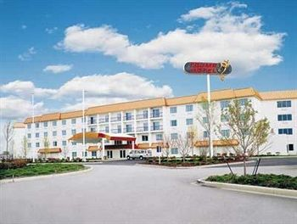
Majestic Star Casino and Hotel at One Buffington Harbor, Gary, Indiana is the Official Host Hotel for the 2013 South Shore Midwest Pocket Billiards Championships. Located off Rt 12 and Cline Ave., the Hotel offers amenities including an indoor pool, and a fitness room. Free Cable T.V., free internet, free coffee and free local calls make the Majestic Star Hotel the ideal place to stay for this tournament. A discounted rate of $59.00 per night is available to pool players. Use Discount Code ‘GMPA Pool’ when you make your reservations. Web site; www.majesticstarcasino.com.

Majestic Star Casino and Hotel
1 Buffington Harbor
Gary, Indiana, 46406
1-888-225-8259

AREA ATTRACTIONS: South Shore Convention and Visitors Association, Lake Michigan Beaches, Dillinger Museum, loads of golf courses, charter fishing, Washington Zoo, Lighthouse Premium Outlet Mall, T.J’s Billiards, and the brand new Griffith Billiards. CHICAGO ATTRACTIONS INCLUDE: Downtown shopping, Magnificent Mile, Navy Pier, Field Museum, Shedd Aquarium, Planetarium, Children’s Museum, Art Museum, Science & Industry Museum, Broadcast Museum, O’Hare Airport, Midway Airport, Old Town, Soldier Field, home of the Chicago Bears, Chicago White Sox Cell One Field, Chicago Cubs Wrigley Field, Chicago Blackhawks, Chicago Bulls at United Center, Chicago Fire, Chicago Sky, John Hancock Center, Willis Tower, Hundreds of Theatres, 10,000 Bars, 20,000 Restaurants, 10,000 Hotels, Trump Tower, Palmer House, Ambassador, thousands of pool places, Original Chris’ Billiards as seen in The COLOR of MONEY, World Famous Red Shoes Billiards, and Nationally acclaimed Pockets Billiards.

Entries may be paid with Credit Cards (Master Card, Visa, through Pay Pal), Cash, Check, Money Order.

